Background:

The variables taken into consideration in this model are the size of the claim, the size of the premium and the probability of a customer making a claim. The size of the claim ,denoted by X, is drawn from a Pareto Distribution with the density function below;

$$f\left(x\right)=\left\{\begin{aligned}0 x≤0 \\ \\ \frac{{αβ}^{α}}{{\left(x+β\right)}^{α+1}} x>0\end{aligned}\right.$$

**1. Basic Calculation and Analysis**

**1.1 Calculating the Cumulative Distribution Function of $X$**

$$F\left(x\right)=P(X≤x)$$

Since $X$ is a continuous random variable, this is obtained by integrating the density function from 0 to $x$

$$F\left(x\right)=\left\{\begin{aligned}0 x≤0 \\ \\ \int_{0}^{x}{\frac{{αβ}^{α}}{{\left(t+β\right)}^{α+1}}dt x>0}\end{aligned}\right.$$

$$\int_{0}^{x}{\frac{{αβ}^{α}}{{\left(t+β\right)}^{α+1}}dt=-β^{α}{(t+β)}^{-α}\left|{x \atop 0}=1-β^{α}{(x+β)}^{-α}\right.}$$

**1.2 Expectation of $X$**

$$E\left(X\right)=\int_{-∞}^{+∞}{xf(x)dx=\int_{0}^{∞}{x∙\frac{{αβ}^{α}}{{\left(x+β\right)}^{α+1}}dx}}$$

$$=\int_{0}^{∞}{(x+β)∙\frac{{αβ}^{α}}{{\left(x+β\right)}^{α+1}}dx}-\int_{0}^{∞}{\frac{{αβ}^{α+1}}{{\left(x+β\right)}^{α+1}}dx}$$

$$=\int_{0}^{∞}{\frac{{αβ}^{α}}{{\left(x+β\right)}^{α}}dx}+β^{α+1}{(x+β)}^{-α}\left|{∞ \atop 0}\right.$$

$$=\frac{{αβ}^{α}}{1-α}{\left(x+β\right)}^{1-α}\left|{∞ \atop 0}-β=\frac{β}{α-1}\right.$$

**Conditions for the parameters:**

$$α>1,β>0$$

$X$ is a positive random variable, therefore clearly $β>0$ leading to a positive mean size of claims. Also $α>1$ for the same reason, ensuring that the basic integration step can be applied. Clearly, $α≠1$ to ensure that the mean size of claim is well defined.

**1.3 Median of $X$**

Let $F\left(x\right)=1-β^{α}{\left(x+β\right)}^{-α}=\frac{1}{2}$

Solving for $x$*,*

$$Median of X=β(2^{1/α}-1)$$

**1.4 Variance of $X$**

By definition,

$$Var\left(X\right)=E\left(X^{2}\right)-{E(X)}^{2}$$

$$=\int_{0}^{∞}{x^{2}∙\frac{{αβ}^{α}}{{\left(x+β\right)}^{α+1}}dx}-{(\frac{β}{α-1})}^{2}$$

$$=\int_{0}^{∞}{{\left(x+β\right)}^{2}∙\frac{{αβ}^{α}}{{\left(x+β\right)}^{α+1}}dx}-2β\int_{0}^{∞}{x∙\frac{{αβ}^{α}}{{\left(x+β\right)}^{α+1}}dx}$$

$$-β^{2}\int_{0}^{∞}{\frac{{αβ}^{α}}{{\left(x+β\right)}^{α+1}}dx}-{(\frac{β}{α-1})}^{2}$$

$$=\int_{0}^{∞}{\frac{{αβ}^{α}}{{\left(x+β\right)}^{α-1}}dx}-\frac{2β^{2}}{α-1}-β^{2}-{(\frac{β}{α-1})}^{2}$$

$$=\frac{{αβ}^{α}}{2-α}{(x+β)}^{2-α}\left|{∞ \atop 0}\right.-\frac{2β^{2}}{α-1}-β^{2}-{(\frac{β}{α-1})}^{2}$$

$$=\frac{{αβ}^{2}}{2-α}-\frac{2β^{2}}{α-1}-β^{2}-{\left(\frac{β}{α-1}\right)}^{2}=\frac{β^{2}α}{{\left(α-1\right)}^{2}\left(α-2\right)}$$

**Conditions for the parameters:**

$$α>2,β>0$$

Variance is strictly positive . Hence $α>2 and β>0$. Clearly $α≠2$, again ensuring that the variance is well defined.

**1.5 The Inversion Method**

1. Generate ui (0,1)
2. Set ui=F(xi) and make xi the subject

$$F\left(x\right)=u$$

$$1-β^{α}{(x+β)}^{-α}=u$$

$$x=β∙{(1-u)}^{-1/α}-β$$

This can be done since F(x) is continuous and strictly increasing based on the restrictions imposed on the parameters.

**1.6 Simulation of 1000 Values Drawn from X**

1. set.seed(123)
2. alpha<-3
3. beta<-100000
4. n<-10000
5. u<-runif(n)
6. x<-beta*(1/((1-u)^(1/alpha))-1)

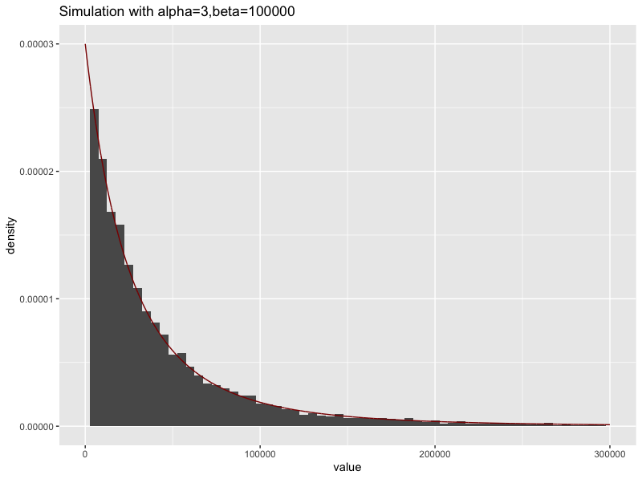Figure 1.1- Histogram of size of claims with the true density function superimposed

**1.7 Reasons for Use of Pareto Distribution to Describe Size of Claims**

* The Pareto Distribution is positively skewed and has a heavy tail on the right.

For this reason, we use Pareto for insurance applications to model extreme

loss,especially for more risky types of insurance,

* It is a mixture of the exponential distribution with gamma mixing weights.
* In financial applications , the study of heavy tailed distributions provides information about the potential for financial failure(bankruptcy)

1. **Models of Year End Assets**

**2.1 Build the Model**

Based on the given information, we built up the expected asset model as follows:

$Z=a+cn-S$*2.11*

$Z$*:* the assets of the company at the end of the year.

$a=250000$ represents the current assets of the company.

$c=6000$ represents the annual premium.

$n=1000$ represents the number of the customers.

Total claim:

$$S=\sum_{i=1}^{N}{X_{i}}$$

$X_{i}\sim$ Pareto distribution i.i.d.

$N=\sum_{j=1}^{1000}{Y_{j}}$: the number of clients making a claim this year.

For $Y_{j} i.i.d$.:

$$\left\{\begin{aligned}P\left(Y_{j}=1\right)=0.1 \\ \\ P\left(Y_{j}=0\right)=0.9\end{aligned}\right.$$

We should calculate the bankruptcy probability:

$$P(Z<0)$$

1. AssetSim<-function(n,premium,prob){
2. balance<-0
3. **for** (k **in** 1:n) {
4. claim<-rbinom(1000,1,prob)
5. cost<-0
6. **for** (i **in** 1:1000) {
7. **if**(claim[i]==1){cost<-cost+rpareto(1,alpha,beta)}
8. }
9. balance[k]<-250000+1000*premium-cost
10. }
11. balance
12. }

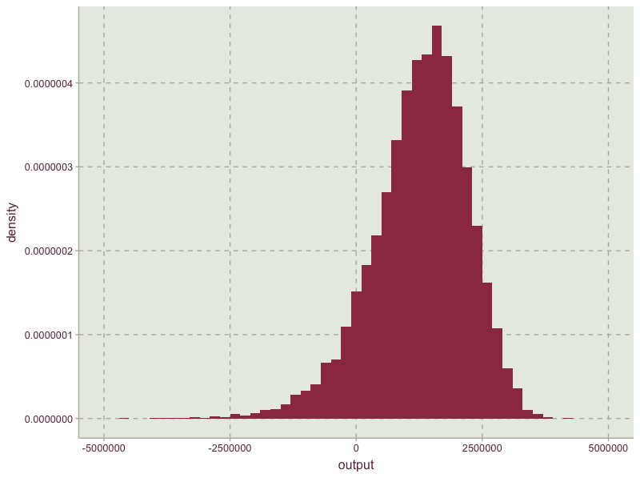

Figure 2-1

As it can be seen from the simulation graph 2-1, the distribution of assets are negatively skewed which clearly coincides with the positive skewness of the Pareto distribution. Assets and Total size of claims are negatively related. S, denoted by the total size of claims here is a combination of the Pareto distribution and the Bernoulli distribution.

**2.2 Impact of Premium and Probability of Making a Claim**

**The effect of premium on probability of bankruptcy**

Throughout this analysis we only change the premium ,whilst controlling for the rest of the variables in the question. We analysed the effects for premium levels ranging from £5500 to £8000 increasing it by £500 each time.

The outcome was as follows:

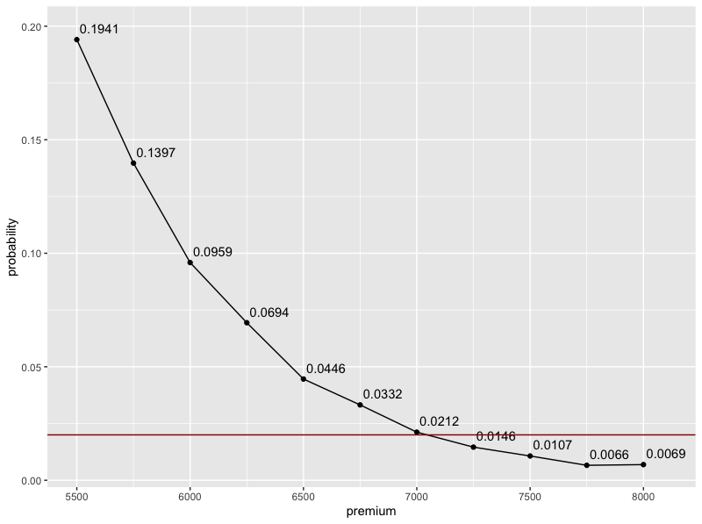

Figure 2-2

|  |  |  |
| --- | --- | --- |
| premium | balance | probability |
| 5500 | 741136.600292234 | 0.1941 |
| 5750 | 1003137.73320141 | 0.1397 |
| 6000 | 1255157.61448557 | 0.0959 |
| 6250 | 1498083.97452799 | 0.0694 |
| 6500 | 1759673.68190743 | 0.0446 |
| 6750 | 2002743.62758197 | 0.0332 |
| 7000 | 2251394.98058984 | 0.0212 |
| 7250 | 2490678.65689442 | 0.0146 |
| 7500 | 2740845.10927589 | 0.0107 |
| 7750 | 2994727.17767397 | 0.0066 |
| 8000 | 3255043.86669691 | 0.0069 |

Table 2-1

Clearly, the probability of bankruptcy declines with an increase of premium levels.

However to ensure that the probability of bankruptcy is no more than 2% we need to charge for a premium of at least £7250.

**The effect of probability of a customer making a claim on the probability of bankruptcy**

Here, we change the probability of a customer making a claim ,controlling for premium and other variables in the question.

The analysis has been carried out for probability ranging from 0.05 to 0.15 increasing it by a 0.005 each time. The outcome was as follows:

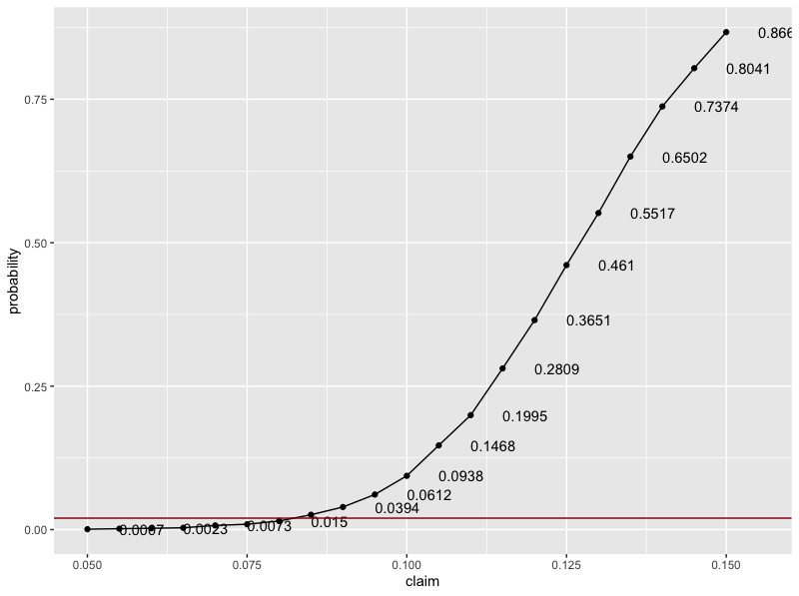

Figure 2-3

|  |  |  |
| --- | --- | --- |
| claim | balance | probability |
| 0.05 | 3759849.64385291 | 0.0007 |
| 0.055 | 3497623.5856642 | 0.0016 |
| 0.06 | 3260109.47219399 | 0.0023 |
| 0.065 | 3009525.64706615 | 0.0032 |
| 0.07 | 2746500.63048726 | 0.0073 |
| 0.075 | 2490617.99967582 | 0.0094 |
| 0.08 | 2243506.9708276 | 0.015 |
| 0.085 | 1998117.96791791 | 0.0259 |
| 0.09 | 1740876.91939939 | 0.0394 |
| 0.095 | 1499039.79317023 | 0.0612 |
| 0.1 | 1251768.85848942 | 0.0938 |
| 0.105 | 993418.842385709 | 0.1468 |
| 0.11 | 754042.482872268 | 0.1995 |
| 0.115 | 502591.533068519 | 0.2809 |
| 0.12 | 252371.527546531 | 0.3651 |
| 0.125 | -1004.49002706269 | 0.461 |
| 0.13 | -242388.017059418 | 0.5517 |
| 0.135 | -497185.30799758 | 0.6502 |
| 0.14 | -746170.992160119 | 0.7374 |
| 0.145 | -991378.617794178 | 0.8041 |
| 0.15 | -1247132.70224009 | 0.8669 |

Table 2-2

We observe a positive trend between the two variables as expected. The higher the chance of a customer making a claim, the higher the claims that the company has to pay for, thus increasing the probability of bankruptcy as premium is fixed.

We also observe an increase in the steepness of the curve

Find the optimal portfolio

|  |  |
| --- | --- |
| Probability | premium |
| 0.05 | 5500 |
| 0.055 | 5500 |
| 0.06 | 5500 |
| 0.065 | 5500 |
| 0.07 | 5500 |
| 0.075 | 5750 |
| 0.08 | 5750 |
| 0.085 | 6250 |
| 0.09 | 6500 |
| 0.095 | 7250 |
| 0.1 | 7250 |
| 0.105 | 7750 |
| 0.11 | 7750 |

Table 2-3

Assumptions

Firstly, we should set a few assumptions especially for the variables selected in our model. Besides the basic assumptions provided , there should be some additional assumptions which ensure that the model is working well.

The first and the second assumption is that for each year, one customer can only make one claim and the probability of customers making a claim is fixed and equal for each customer. Claims are made independently of each other and of customers. That is, there is no probable situation that the decision of one customer could be influenced by another .

For simplification purposes, we also assume that the value of the premium is fixed irrespective of the size of the claim. Practically speaking, we assume that every customer of the insurance company will buy identical products with equal premium. Besides, we don’t consider the situation that some of the customers drop out at any circumstance. For instance, some customers might quit due to the increasing of premium when a financial crisis happens.

In real insurance contract, when customers buy insurance to protect themselves against unforeseen risks, they should agree to pay for the first part of the future loss. This part paid by customers is the so-called deductible, which has also been dropped in the model provided above. We have assumed instead that the company will pay the entire loss for customers, which potentially increases the probability of bankruptcy.

In corporate finance, the calculation of total assets needs specific data from financial statements. To simplify the calculating procedures, we assume that the company will retain all premiums charged with itself and not engage in any transactions like borrowing to cover the losses incurred.

Factors that the company can control

Based on the assumptions and outcomes of simulation, there are factors that can be controlled by the company in order to reduce the risk of bankruptcy.

The first factor that the company should pay more attention to is the premium. In this case, to ensure that the risk of bankruptcy is less than 2%, the minimum premium that the company should charge is £7250. It is best if the company can stand firm with this pricing which will indeed improve the company’s reputation too.

The second factor is probability of customers making a claim. The company can forecast the probability of a customer making a claim before accepting customers and accept those who are at most 8% likely to make a claim. This in turn can ensure the risk of bankruptcy to be less than 2% based on the previous calculation.

Besides, the company can also find the relationship between number of claims made per year and the risk of bankruptcy and then limit to the maximum number of claims with minimal risk.

Apart from the technical advices, there are also non-technical factors which the company can control. The company should not wait till the net balance has reached to zero to calculate the risk of bankruptcy. That is, the company should always keep itself updated with the evaluations. On the other hand, the company can mitigate its risk by exploring the option of reinsurance, which can spread the risk to other financial institutions. The company should also conduct frequent seminars, providing advice to minimize avoidable risks and network with the customers.

However, the results based on our prediction are not absolute. We should make some adjustments when we are considering specific scenarios. For example, we assumed that probability of each customer making a claim in a year to be 0.1, but that can be quite different when we consider factors such as the age, gender, income of the customers. Also, claims made by customers are not always independent from each other. We believe there are some clients of your company who are friends or relatives and you cannot avoid them discussing their opinions or sharing their feedback about products. They might arrive at similar conclusions of whether to continue to invest in the company, so public praise is quite important for our company. This should be strongly focused on. We also hope you can provide us with more previous data, especially the amount of claims made each time which can help us simulate the distribution and make a better prediction because in the model assumed, the parameters were based on general circumstances for this kind of insurance, while it varies among different companies and client groups.

Based on these disadvantages, a more suitable model has been formulated below. The time period has been extended to ten years because we should have a long-term consideration and not just focus on the end of this year. The fluctuation of number of customers every year and the scenario that a customer may make more than one claim per year have also been considered. In the analysis, we have concluded that the risk of bankruptcy increases with time. But if we can overcome the difficulties and exclude some less probable events ( claims exceeding average levels), we can expect the assets of our company to increase continuously. Based on the parameters used ,the risk of bankruptcy in ten years is 0.1456 which is a little high for us. A suggestion is to increase the annual premium to ￡7,500 which in turn did reduce the risk of bankruptcy to 0.02, which is exactly our goal.

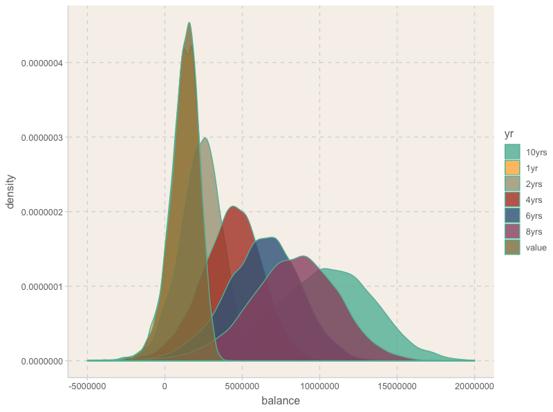

Appendix

The extended model:

Assumptions:

1. Consider 10 years’ time period
2. The number of customers is not fixed every year and the premium is not necessarily paid at the start of a year. The total number paying for annual premium has a Poisson distribution.
3. The probability of customers making a claim is not identical for everyone. Assume the number of times making a claim also has a Poisson distribution.

The equation of new model:

$$Z(t)=a+cM(t)-S(t)$$

$Z(t)$: the assets of the company at the end of the year $t$.

$a=250000$ represents the current assets of the company.

$c=6000$ represents the annual premium.

$M(t)$: the number of times for paying for premium until year $t$. It has a Poisson distribution of parameter $λ_{1}t$. The pdf of $M(t)$ is:

$$P\left(M\left(t\right)=k\right)=\frac{{\left(λ_{1}t\right)}^{k}}{k!}e^{-λ_{1}t}, k=0,1,2…$$

Total claim till the end of year $t$:

$$S(t)=\sum_{i=1}^{N(t)}{X_{i}}$$

$X_{i}\sim$ Pareto distribution i.i.d.

$N(t)$: the number of claims made until year $t$. It has a Poisson distribution of parameter $λ_{2}t$. The pdf of $N(t)$ is:

$$P\left(N\left(t\right)=k\right)=\frac{{\left(λ_{2}t\right)}^{k}}{k!}e^{-λ_{2}t}, k=0,1,2…$$

Assume $λ_{1}=1000$, $λ_{2}=100$, we can simulate the assets of the company in the end of year t and compare the probability of bankruptcy at the end of each year.

1. PoisSim<-function(n,t,premium,lambda1,lambda2){
2. balance<-matrix(0,n,t)
3. **for** (k **in** 1:n){
4. **for** (i **in** 1:t) {
5. num<-rpois(1,lambda2)
6. claim<-sum(rpareto(num,alpha,beta))
7. **if**(i==1){
8. balance[k,i]<-250000+premium*rpois(1,lambda1)-claim
9. }
10. **else**{
11. balance[k,i]<-balance[k,i-1]+premium*rpois(1,lambda1)-claim
12. }
13. }
14. }
15. balance
16. }
17. ######1
18. rm(list=ls())
19. library(ggplot2)
20. library(dplyr)
21. library(actuar)
22. library(ggthemr)
23. library(tidyr)
24. set.seed(123)
25. alpha<-3
26. beta<-100000
27. n<-10000
28. u<-runif(n)
29. x<-beta*(1/((1-u)^(1/alpha))-1)
30. options(scipen = 200)
31. z=seq(0,299970,30)
32. data.frame(value=x)%>%
33. ggplot(.,aes(x=value))+geom_histogram(aes(y=..density..),binwidth = 5000)+
34. geom_line(aes(z,dpareto(z,alpha,beta)),color="darkred")+
35. xlim(0,300000)+ggtitle("Simulation with alpha=3,beta=100000")
36. ######2
37. AssetSim<-function(n,premium,prob){
38. balance<-0
39. **for** (k **in** 1:n) {
40. claim<-rbinom(1000,1,prob)
41. cost<-0
42. **for** (i **in** 1:1000) {
43. **if**(claim[i]==1){cost<-cost+rpareto(1,alpha,beta)}
44. }
45. balance[k]<-250000+1000*premium-cost
46. }
47. balance
48. }
49. output<-AssetSim(10000,6000,0.1)
50. summary(output)
51. ggthemr("grape")
52. ggplot(as.data.frame(output),aes(x=output))+geom_histogram(aes(y=..density..),binwidth = 200000)+xlim(-5000000,5000000)
53. cat(paste("The expected asset: ",mean(output)))
54. cat(paste("The probability of bankrupt: ",mean(output<0)))
56. #######3
57. premium<-seq(5500,8000,250)
58. prob<-seq(0.05,0.15,0.005)
59. dt1<-data.frame(premium=premium, balance=0,probability=0)
60. dt2<-data.frame(claim=prob, balance=0,probability=0)
61. **for** (i **in** 1:length(premium)){
62. output<-AssetSim(10000,premium[i],0.1)
63. dt1$balance[i]<-mean(output)
64. dt1$probability[i]<-mean(output<0)
65. }
66. p<-ggplot(dt1,aes(premium,probability))+geom_text(aes(label=probability),check_overlap=TRUE,nudge_y=0.005,nudge_x=100)+geom_point()+geom_line()
67. p+geom_hline(aes(yintercept = 0.02),colour="dark red")
68. cat("Minimal premium level:",min(dt1$premium[dt1$probability<0.02]),"\n")
70. **for** (i **in** 1:length(prob)){
71. output<-AssetSim(10000,6000,prob[i])
72. dt2$balance[i]<-mean(output)
73. dt2$probability[i]<-mean(output<0)
74. }
75. p<-ggplot(dt2,aes(claim,probability))+geom_point()+geom_text(aes(label=probability),check_overlap=TRUE,hjust=0,nudge_x=0.005)+geom_line()
76. p+geom_hline(aes(yintercept = 0.02),colour="dark red")
77. cat("maximal probability of making a claim:",max(dt2$claim[dt2$probability<0.02],"\n"))
79. #### find optimal portfolio
80. prob<-as_tibble(prob) %>%mutate(premium=0)
81. **for** (i **in** 1:length(prob$value)){
82. j=1
83. **while** (j <=length(premium)) {
84. prob0<-mean(AssetSim(1000,premium[j],prob$value[i])<0)
85. **if**(prob0<0.02){
86. prob$premium[i]<-premium[j]
87. **break**}
88. j=j+1
89. }
90. }
92. ###extending model
93. ##control lambda1=10000, lambda2=1000
94. PoisSim<-function(n,t,premium,lambda1,lambda2){
95. balance<-matrix(0,n,t)
96. **for** (k **in** 1:n){
97. **for** (i **in** 1:t) {
98. num<-rpois(1,lambda2)
99. claim<-sum(rpareto(num,alpha,beta))
100. **if**(i==1){
101. balance[k,i]<-250000+premium*rpois(1,lambda1)-claim
102. }
103. **else**{
104. balance[k,i]<-balance[k,i-1]+premium*rpois(1,lambda1)-claim
105. }
106. }
107. }
108. balance
109. }
110. out<-PoisSim(10000,10,6000,1000,100)
111. **is**.neg<-apply(out,1,function(row) any(row<0))
112. length(which(**is**.neg))/10000
114. Summary_table<-as_tibble(output) %>% mutate("1yr"=0,"2yrs"=0,"4yrs"=0,"6yrs"=0,"8yrs"=0,"10yrs"=0)
115. Summary_table[2]<-out[,1]
116. Summary_table[3]<-out[,2]
117. Summary_table[4]<-out[,4]
118. Summary_table[5]<-out[,6]
119. Summary_table[6]<-out[,8]
120. Summary_table[7]<-out[,10]
121. new_table<-gather(data=Summary_table,key="yr",value="balance",value,"1yr","2yrs","4yrs","6yrs","8yrs","10yrs")
122. ggthemr("light")
123. ggplot(new_table,aes(x=balance,fill=yr))+geom_density(alpha=.8)+theme(legend.position = "right")+xlim(-5000000,20000000)
125. #build functions to find out the bankrupcy probability
126. ProbOfBank<-function(n,t,premium,lambda1,lambda2,threshold){
127. outcome<-PoisSim(n,t,premium,lambda1,lambda2)
128. **is**.neg<-apply(outcome,1,function(row) any(row<threshold))
129. length(which(**is**.neg))/n
130. }
132. dt3<-data.frame(premium=seq(5500,8000,250),prob=0)
133. **for** (i **in** 1:length(premium)){
134. dt3$prob[i]<-ProbOfBank(1000,10,premium[i],1000,100,0)
135. }
136. cat("Minimal premium level:",min(dt3$premium[dt3$prob<0.02]),"\n")
137. write.csv(prob[1:13],"result.xlsx",applend=TRUE)